**Practical No 01**

**Title** - Explore WEKA

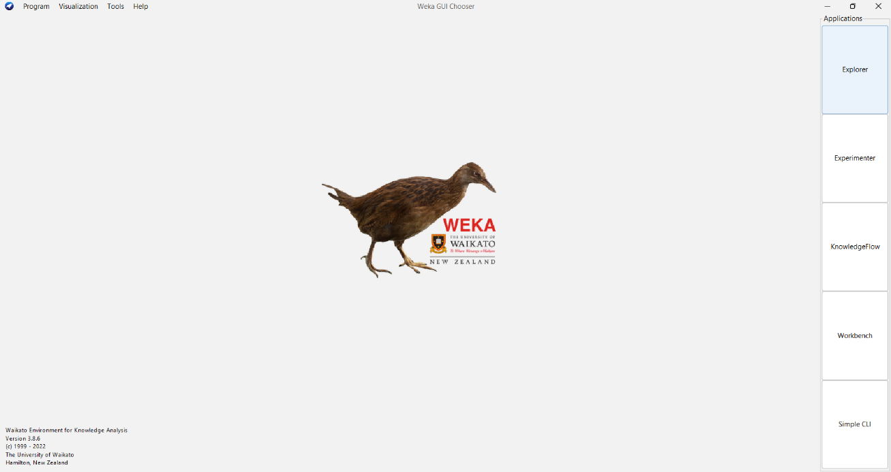Install The weka Tool from “<https://sourceforge.net/projects/weka/>” and Run it And following images shows about the Weka Tool intetrface and the attributes of Weka Tool

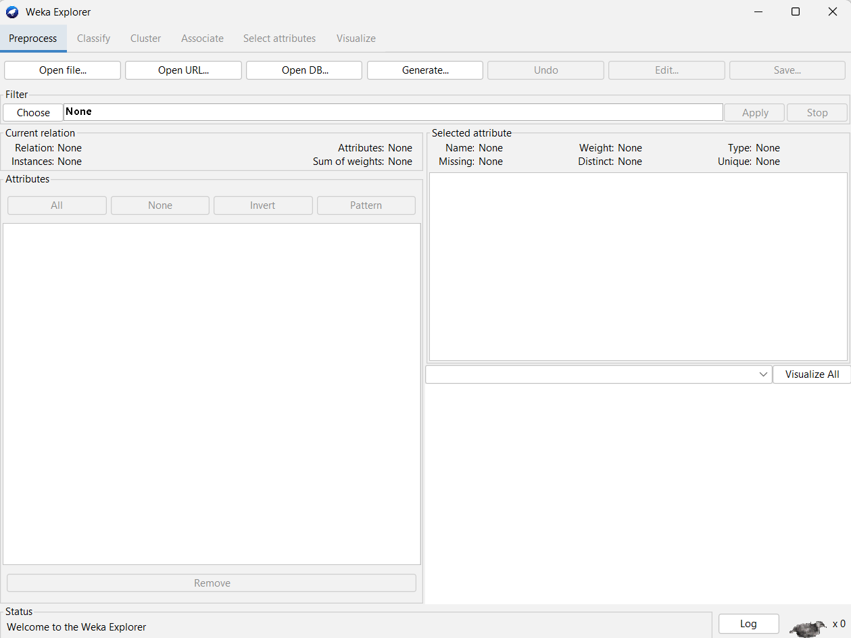Explore –

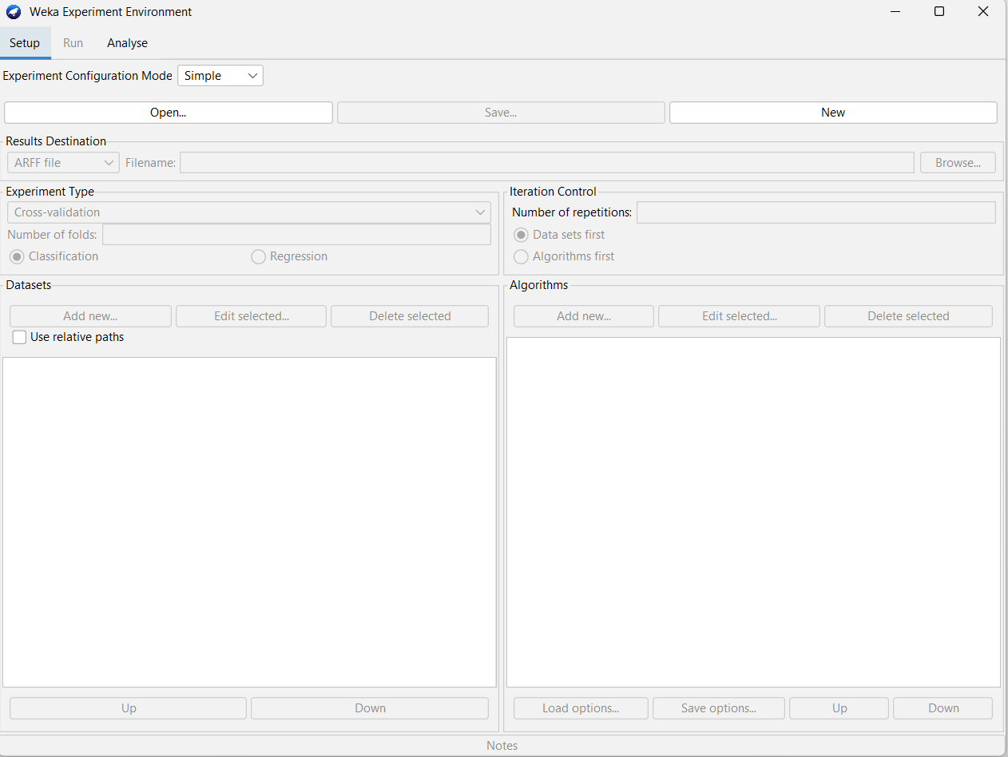Expeiement –

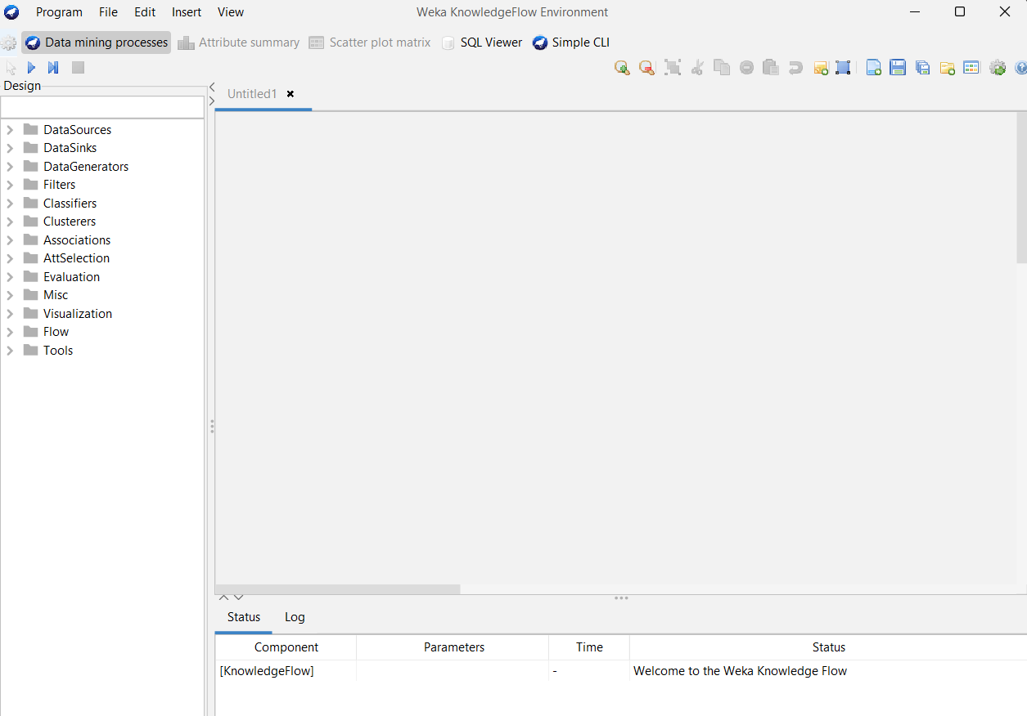Knowledgw Flow -

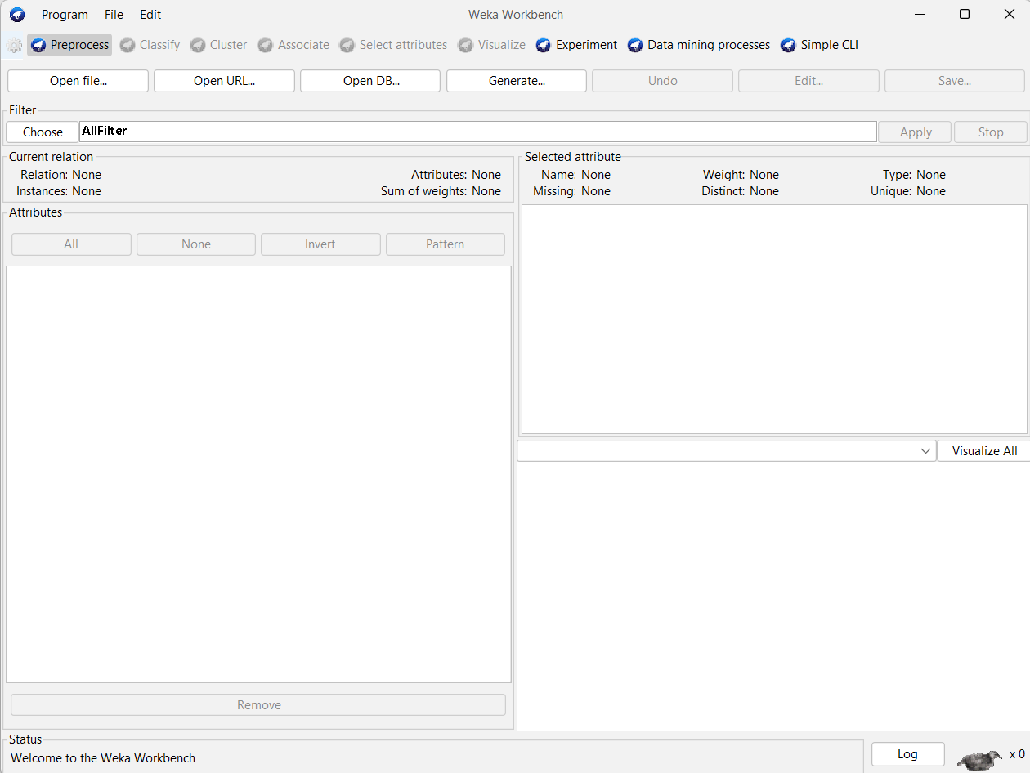WorkBench

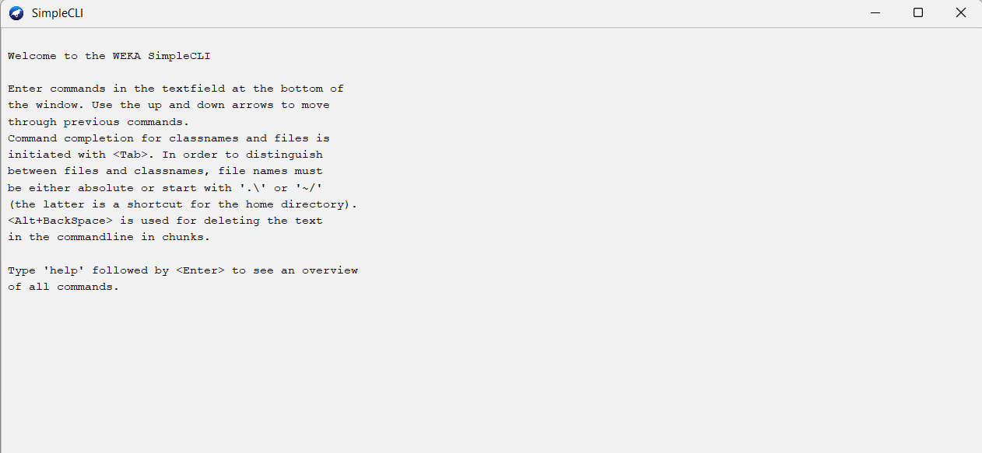Simple CLI –